UNVELLING MARKET INSIGHTS: ANALYSING SPENDING BEHAVIOUR AND IDENTIFYING OPPORTUNITIES FOR GROWTH

**TEAM MEMBERS**

* H.THARANI ESWARI
* M.TAMIL SELVI
* S.VINDHYA
* S.KOWSHIKA

1. INTRODUCTION

1.1 OVERVIEW

The challenge for any business is to gain a sufficiently detailed understanding of the fundamentals of a market. Without this insight, if is unlikely that marketing strategies will prove effective or that marketing objectives will be met.

Gaining this understanding is the task of market analysis.

* 1. PURPOSE

Market analysis is a detailed assessment of your business’s target market and the competitive landscape within a specific industry. This analysis lets your project the success your can expect when your introduce your brand and its products to consumers within the market.

2. PROBLEM DEFINITION AND DESIGN THINKING

2.1 EMPATHY MAP

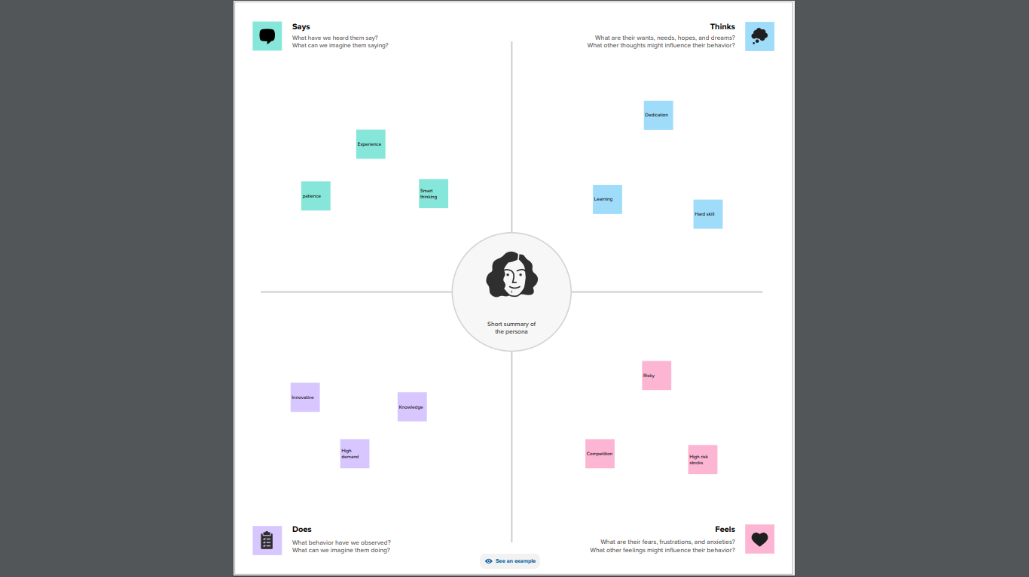

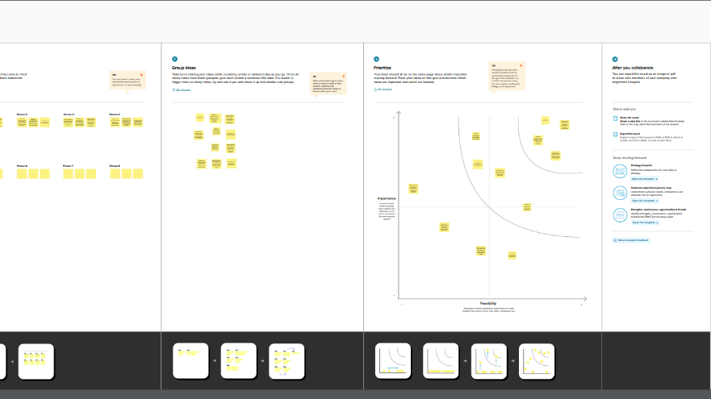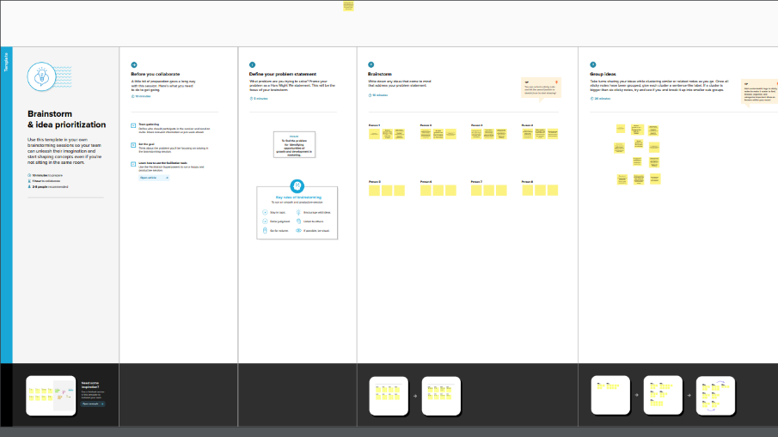2.2 IDEATION AND BRAINSTROMING MAP

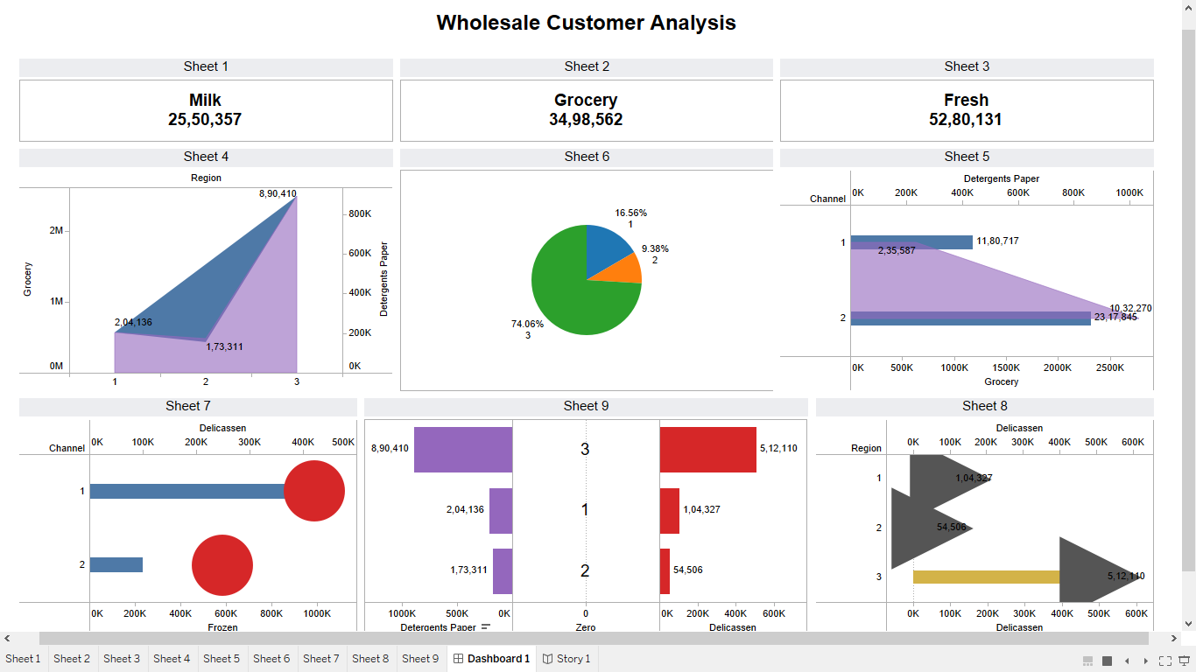3.RESULT

4. ADVANTAGES AND DISADVANTAGES

Some of the advantages and disadvantages of unvelling market insights

ADVANTAGES

* Increasing market share.
* Allows for a more personal relationship between the business and the customer.
* Raising brand awareness.
* Options of current and former customers can identify areas for improvement.
* Marketing that is properly researched and targeted will bring new and returning customers.

DISADVANTAGES

* Time-consuming and expensive compared to secondary research.
* Require resources for survey design, data collection, and analysis.
* A limit sample size may not represent the entire target market.
* The disadvantages of doing this is twofold. You may overestimate how well your competition is meeting the customer’s needs and quit before you even try to market. You also may misidentify the need that is being met. Don’t overlook the uniqueness of your own offering.

5. APPLICATIONS

Behavioral sciences have made significant contributions to informing us about human decision marketing. In, this study, we recount our expensive from incorporating these insigths into business to business market research. We share the insights gained from this endeavor, particularly how we deal with the obstacles are the overwhelming quantity of behavior insigths into the literature, the lack of practical guidelines for their use, and the problem of their communicating their added value to clients.

6. CONCLUSION

A good marketing plan includes how the organization should respond to various scenarios if the market changes. In addition, the plan should include “triggers” detailing what should happen under the scenarios. For example, it might specify that when a certain percentage of market share is reached, then the price of the product will be reduced.

7. FUTURE SCOPE

The future scope of market research plays a critical role in providing insights and data to business and organisations that help them make informed decisions. As the global market continues to evolve and scope of market research is constantly changing.